**Shri G.S. Institute of Technology and Science**

**INDORE**



**Department of Information Technology and Application**

**MCA Iˢᵗ Year**

**IIⁿᵈ Semester**

**January-June 2025**

**Report**

**Topic: Process Scheduling Simulation**

SUBMITED TO SUBMITTED BY

Ms. Shweta Gupta Paridhi Soni - 0801CA241098

Rajat Bhopte - 0801CA241110

# 1.Abstract

The Process Scheduling Simulation project is an educational and interactive tool created to provide insights into the inner workings of CPU scheduling algorithms. It visually simulates how different scheduling strategies impact the execution and efficiency of processes in operating systems. Through this simulation, users can understand various metrics like turnaround time, waiting time, and CPU utilization, making it ideal for students, educators, and system enthusiasts.

# 2. Table of Contents

Introduction  
History  
Architecture  
Applications  
Merits and Demerits  
Conclusion  
References  
Appendices

# 3. Introduction

Operating systems manage multiple processes simultaneously, making efficient CPU scheduling essential for performance. This simulator showcases several CPU scheduling techniques, demonstrating how they operate and what metrics they affect. It is designed as a visual aid and practical tool for learners.

# 4. History

CPU scheduling algorithms have evolved to solve performance and fairness problems in time-sharing systems. Early methods like First-Come, First-Served were simple, but modern needs led to more efficient methods like Round Robin and Priority Scheduling.

# 5. Architecture

The simulator is built with an interactive UI that allows users to input custom process details:

* Arrival time
* Burst time
* Time quantum (for Round Robin)

It supports the following algorithms:

* First-Come, First-Served (FCFS)
* Shortest Job First (SJF)
* Round Robin (RR)

**Gantt chart visualizations show process execution in real-time.**

# 6. Applications

* **Educational Use**: Helps students understand scheduling algorithms practically.
* **Performance Testing**: Demonstrates how different scenarios affect scheduling performance.
* **Visualization Tool**: Useful in lectures or demos to explain scheduling behavior.

# 7. Traits

**Merits:**

* Easy to use UI
* Clear visualization using Gantt Charts
* Real-time metrics calculation (turnaround time, waiting time)
* Supports preemptive and non-preemptive algorithms

**Demerits:**

* Limited to CPU scheduling (no I/O modeling)
* May not scale well for very large inputs

# 8. Conclusion

This simulator serves as a hands-on tool for understanding and comparing CPU scheduling strategies. By allowing users to interact with various algorithms and analyze results visually, it bridges the gap between theory and practice.

# 9. References

* Operating System Concepts by Silberschatz, Galvin, and Gagne
* Online OS simulation tools
* Research papers and academic notes on process scheduling

# 10. Appendices

**Screenshots**:

1. Initial screen

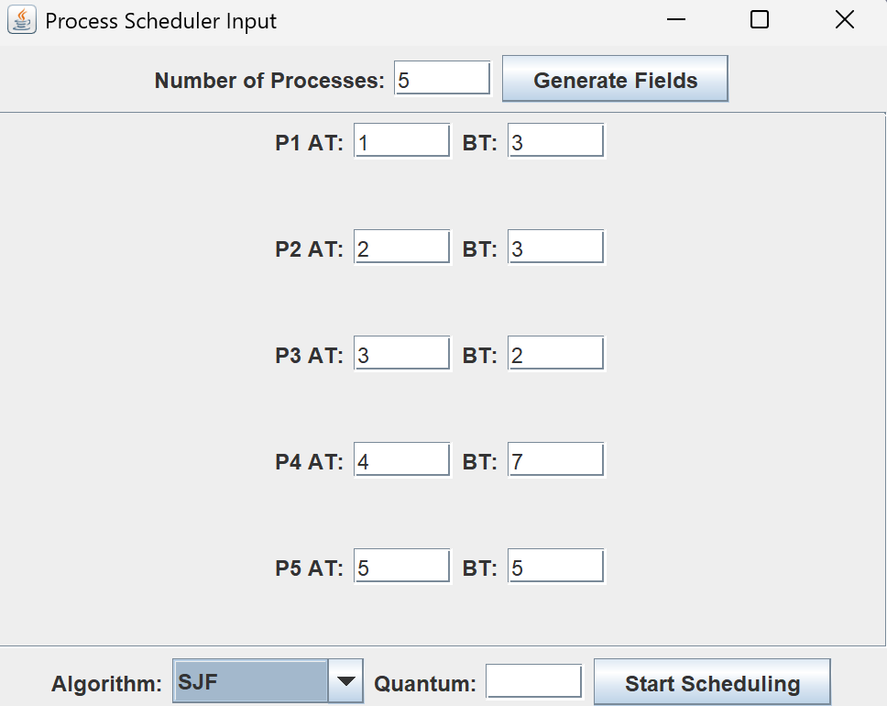

1. Algorithm input selection screen

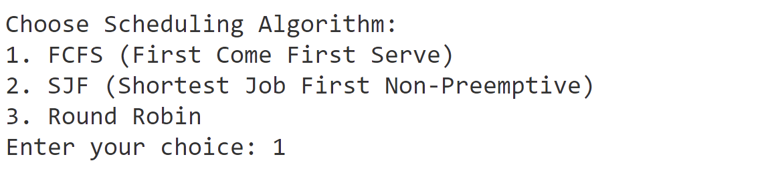

1. Output table with calculated times

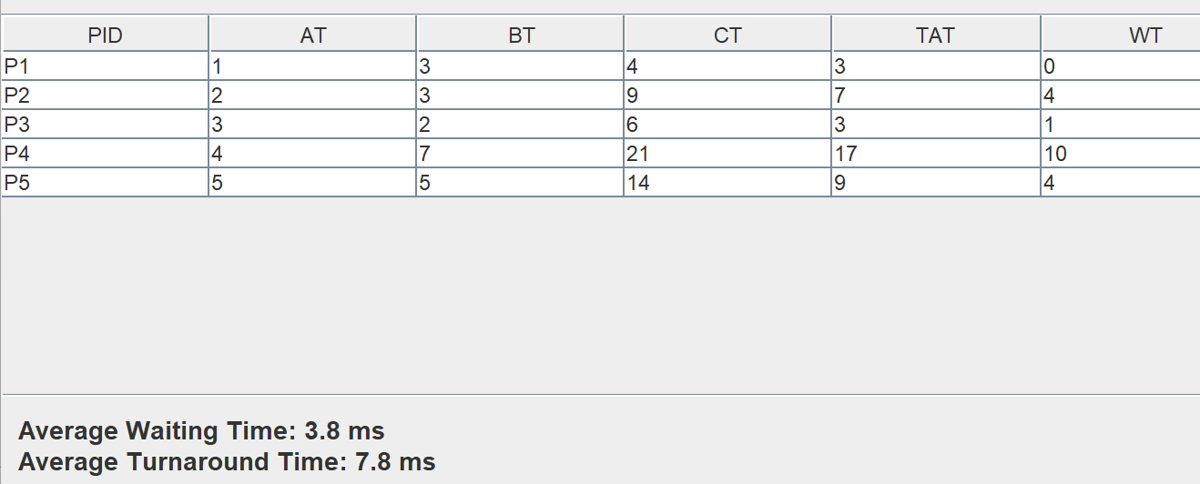

1. Gantt chart visualizations show process execution in real-time.

